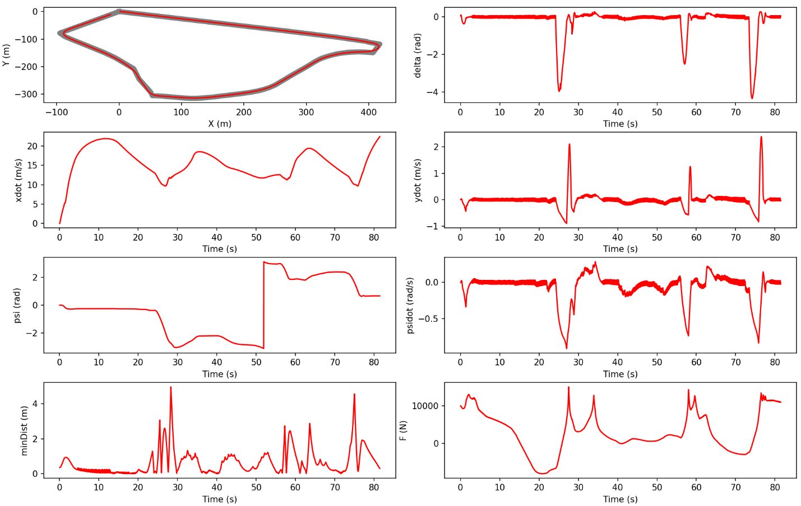

Score for completing the loop: 30.0/30.0

Score for average distance: 30.0/30.0

Score for maximum distance: 30.0/30.0

Your time is 81.44

Your total score is : 100.0/100.0

total steps: 81440

maxMinDist: 4.9606087083385235

avgMinDist: 0.6589714338454759